**Basic exploration of your IoT data with Pandas and plotting with Matplotlib**

As we learned in the recent [blog post](https://home-assistant.io/blog/2016/07/19/visualizing-your-iot-data/), all operational data of your Home Assistant application is stored locally and is available for exploration. Our first steps were querying data with the [DB Browser for SQLite](http://sqlitebrowser.org/), exporting the data extract as a CSV file and graphing in LibreOffice. What else can be done with this data and what tools are there available? This post will utilize [Pandas](http://pandas.pydata.org/) (an open source tool for data analysis for Python), [matplotlib](http://matplotlib.org/) (a Python plotting library); and finally wrap up some ready-to-use code for visualizing aesthetically-sound plots in a [Jupyter notebook](https://jupyter.org/) (application for creation and sharing of documents containing live code, visualizations and explanatory text). All stored and processed locally.

**Dependencies**

In order to run the provided Jupyter notebook, please make sure you have the following applications\libraries installed on your computer:

* Pandas
* NumPy
* [Microsoft Visual C++ Compiler](http://www.microsoft.com/en-us/download/details.aspx?id=44266)
* Matplotlib
* SQLAlchemy
* Jupyter

As a Windows user myself, I find the easiest, quickest and most hassle-free way of installing all of these dependencies is to use [WinPython](https://winpython.github.io/). This free open-source portable distribution includes all of the dependencies required for this notebook, as well as a few other essential Python libraries you may require for data exploration in the future.

**Why Jupyter?**

While all Home Assistant implementations can have varying setup, components and scripts, the underlying data structure is standardized and well-defined. This allows us to write Python code that is environmentally agnostic, and wrapping it in a Jupyter notebook ensures the code, visualizations and directions\explanations are kept digestible and neatly-packaged. One of the amazing features of Jupyter is the ability to change code as you go along, customizing all outputs and visualizations *on the fly!*

**Where do I start?**

Once you have installed the above dependencies, launch the Jupyter Notebook App, click the ‘Upload’ button to locate and open the attached Jupyter Notebook and edit the DB_URL variable (your database url as specified in configuration.yaml). That’s it! The included code will walk you through importing the required libraries, show running raw SQL against your local database, plotting basic data from the states table, and in the end output a few plots of changes for every entity in your system as well as the mean daily value for the past 20 days.

After just those few steps, you will be greeted with beautiful formatted data like this:

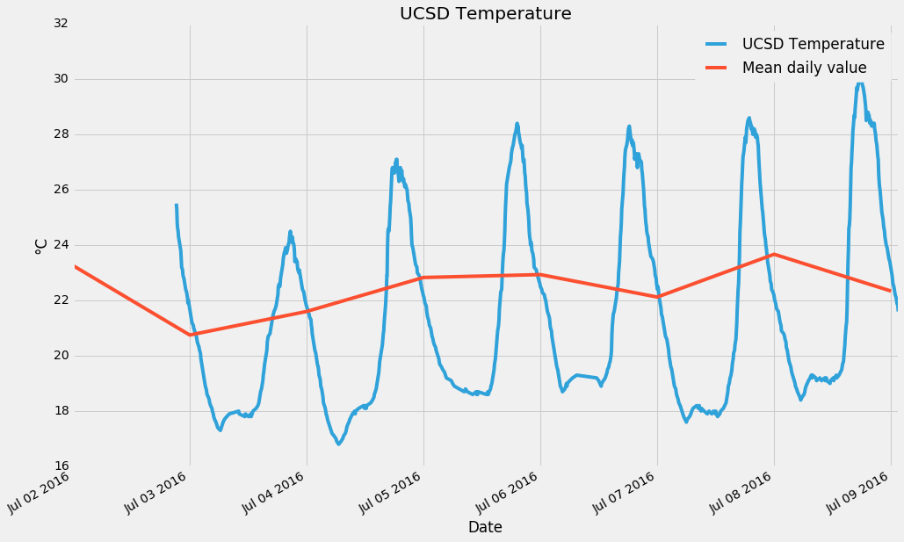

**What’s next?**

Thanks to the magic of Jupyter, all of the code is customizable: want to selectively display your data, only covering a specific entity? Sure thing! Want to change the properties of the plots? No problem!

While you learn and explore your IoT data, we will be working on providing more ready-to-use Jupyter Notebooks. Feel free to ask questions or provide suggestions. Would you like to see a specific visualization? Is there a particular facet of data you’re interested in? Let’s talk about it, let’s dive into the world of data together!